CME Frequently Asked Questions

Thank you for your interest in offering a Continuing Medical Education (CME) activity.

The University of Miami CME office evaluates new activity proposals to ensure they are consistent with the University of Miami Miller School of Medicine mission, goals and objectives.

Before beginning an application and for more detailed information regarding CME accreditation requirements, please contact:
Oscar Reyes, Director
Division of Continuing Medical Education
Direct: 305.243.6716
oreyes@med.miami.edu

- The Application must be completed online and is found here:
University of Miami Division of CME Activity Planning Form Submissions (cloud-cme.com)
- Click on “Create New Application” to begin.
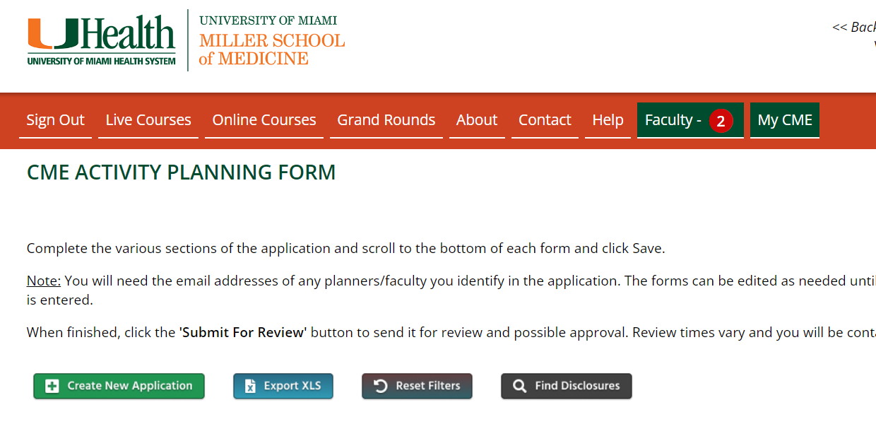
- You may close out of the application and return to make edits at any time as long as you fill out all the required (red boxed) questions in that section.
- Hit “Save and Continue” at the end of each section to proceed to the next section.
- Once finished with the application, click the “Submit to Review” button on your application screen.

- Disclosure Forms:
- Disclosure forms are completed directly online.
- After including the activity director, planning committee members, and presenters on the application, each will receive an email requesting him/her to complete an online disclosure form. If there is an online disclosure already in the system, the course coordinator will need to confirm with the presenter that the disclosure is accurate and up to date.

- CME Fees: Please discuss fees with your designated CME Manager.

What types of Accreditations do you offer?
- AMA PRA Category 1 Credit™
The University of Miami Leonard M. Miller School of Medicine is accredited by the Accreditation Council for Continuing Medical Education to provide continuing medical education for physicians.
- Pychology Credit
The University of Miami Leonard M. Miller School of Medicine is approved by the American Psychological Association (APA) to sponsor continuing education for psychologists. The University of Miami Leonard M. Miller School of Medicine maintains responsibility for this program and its content.
- Nursing Credit
Upon request, nursing credit may be applied for on behalf of the course

Who do I contact for Social Work credit?

Jackson Memorial Health
Odalys M. Bancroft
Email: odalys.bancroft@jhsmiami.org

Sylvester Comprehensive Cancer Center
Lisa Marie Merheb, MSW, LCSW
Director of Social Services, Oncology
Sylvester Comprehensive Cancer Center
Direct: 305-243-4105
Email: LMerheb@med.miami.edu

Who is responsible for submitting the CME application?
The planning team is responsible for completing the CME application and presenting the program for CME activity approval.
The planning team typically includes the:
- Activity Director(s), usually a UM faculty member, who coordinates the activity planning process
- Planning committee
- Coordinator

When should I submit the CME application?
It is strongly suggested that applications be submitted 3-9 months in advance of the activity date. Applications received less than 3 months prior will be accepted at the discretion of the CME Director and may be subject to late fees.

Can I use the old CME Application documents?
No. Effective immediately, the online forms must be completed.
Do I need to get approval to advertise the course?
Yes! All communications, including online publications and or printed materials (advertising, brochures, Webpages and social media), must be reviewed/approved by the Division of CME Manager PRIOR to any marketing collateral being published, printed or distributed.
Who signs the Letters of Agreement (LOA)?
The CME Director. As per the ACCME, all LOAs must be fully executed (signed by both the Commercial Interest/designated grant officer and the UM CME Director) before the CME activity start date. Otherwise, it is not valid, and funds may not be accepted.
What is a CME-Managed course?
These are courses certified by the Division of CME and includes conference logistics management.
What services does the CME conference logistics management include?
UM Division of CME provides integral involvement in the educational planning, including needs assessment, objective setting, target audience identification, activity development and evaluation, including:
- Strategic Planning
- The Division of CME manages all aspects of conference finances:
  - Budget creation and submission to Department Administrator and Medical finance for approval
  - Income and expense management
  - Budget reconciliation
  - CME Division’s expertise of the University’s finance policies and procedures expedites vendor services and speaker honoraria/expenses
  - A Profit and Loss (P&L) is conducted after each course striving for a profit or breakeven
- The University requires that before any conference takes place, it must be approved by Medical Finance. The Division of CME manages this process by ensuring that upon Department Chairman and Administration budget approval.
- On- and Off-Campus Site Selection and Contract Negotiation
- Faculty/Speaker Management
- Syllabus Production
- Food and Beverage Planning and Management
- On Site Registration and Event Management
- Audio Visual Coordination
- Commercial Support Management: Grants, Exhibits and/or Sponsorships
- Audience Development
  - Distribution List Procurement
- Marketing collateral: Graphic design, distribution and layout
  - Brochure
  - Save-the-Date Announcements
  - Course website
  - Journal ads

What is a Department-Managed course?
These are courses that are certified by the Division of CME but are managed by the individual University of Miami department.
What is a Jointly Provided Activity?
The ACCME defines joint providership as the providership of a CME activity by one or more accredited and one or more non-accredited organizations. Therefore, ACCME-accredited providers that plan and present one or more activities with non-ACCME accredited providers are engaging in “joint providership.” Please note: The ACCME does not intend to imply that a joint providership relationship is an actual legal partnership. Therefore, the ACCME does not include the words, “partnership” or “partners” in its definition of joint providership or description of joint providership requirements.
The accredited provider must take responsibility for a CME activity when it is presented, in cooperation with a non-accredited organization and must use the appropriate accreditation statement.
What precautions for COVID-19 are being used for in-person attendees?
In partnership with the conference venue we will adhere to all official guidance from municipal and national government health authorities, as well as any venue-specific regulations aimed at mitigating the spread of COVID-19. We will continue to monitor the evolving situation and will update our strategy and guidelines as needed.
Regardless of COVID-19 vaccination or testing status, all attendees will be required to wear facemasks when indoors or when they are unable to socially distance from one another pursuant to current US Centers for Disease Control and Prevention (CDC) guidance.
In the event of future changes in applicable law or guidance, we may change our requirements.
Florida Travel and Safety
https://www.visitflorida.com/more/current-travel-safety-information/covid-travel-safety-information/

Why Accredited CME Matters?
The fields of medicine and science never stop moving forward - and neither should physicians.
Aspiring physicians spend four years in medical school and three to five years in residency training. For the rest of their careers, physicians rely on accredited CME as one of the support systems that helps them drive improvements in practice and optimize the care, health, and wellness of patients.
Accredited CME addresses every medical specialty, covering the full range of topics important to healthcare improvement. Whether physicians work in clinical care, research, healthcare administration, executive leadership, or other areas of medicine, accredited CME is designed to be relevant to their needs, practice-based, and effective.
Participation in accredited CME helps physicians meet requirements for maintenance of licensure, maintenance of certification, credentialing, membership in professional societies, and other professional privileges.
Physicians can count on accredited CME to provide a protected space for them to learn and teach without commercial influence.
Clinicians are expected to deliver safe, effective, cost-effective, compassionate care, based on best practice and evidence. Accredited CME helps make that happen.

Related Links
ACCME Accreditation Criteria
Standards for Integrity and Independence in Accredited Continuing Education
AMA PRA Booklet

