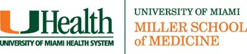

Release for Use of Conference Audio, Video, and/or Digital Recordings and Materials

I, , hereby authorize the University of Miami to audio/video tape-record or digitally record or copy my lecture or presentation recording made during the Medical Grand Round Conference: “ ” on .

I understand that those recordings and/or the materials, outlines, etc provided or used as part of my presentation can be used in whole or in part by the University, its agents or assigns for any purposes and any form or medium whatsoever without further permission from me. I acknowledge and understand that the use of these recordings and materials may result in commercial benefit to the University of Miami of which I agree I will not share in any proceeds. This consent does not deprive me of any other rights I may have in my lectures or discussion material and in no way prohibits me from using my own material in anyway I do desire.

Printed Name:

Date:

By checking this box and typing my name and date in the signature line above, I am providing my electronic signature approving all the information entered above.

Grand Rounds Information Request Form

